VMW 261: In-class quiz #3

|  |  |
| --- | --- |
| Name: |  |

**Instructions**

Read each question carefully and circle the correct answer. When you are done, bring your quiz up to Russ ☺

1. Which of these is the first step of flowering?
   1. Pollen germinates and forms a pollen tube
   2. The development of an embryo
   3. The anthers well and burst open the cap
   4. Male and female gametes fuse in the ovule
2. Which of these conditions can inhibit pollen tube growth and limit fertilization?
   1. Temperatures between 75oF – 85oF
   2. Temperatures between 65o – 85oF
   3. Temperatures between 40 - 50oF
   4. Temperatures between 85oF – 95oF
3. What is this condition known as?

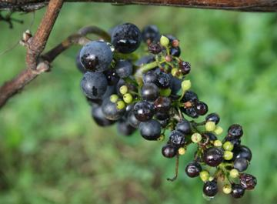

* 1. Millerandage
  2. Shatter
  3. Hens and chicks
  4. Good set

1. What is a likely cause of the condition in question 3?
   1. Cold weather at flowering
   2. N deficiency
   3. Low vigor
   4. Open fruit zones
2. Stomata are_________
   1. Closed during the day
   2. Closed during the night
   3. Open during the night
   4. Always open

**Extra credit**

1. Water deficit from fruit set until veraison can__________
   1. Cause a reduction in berry size
   2. Increase cellular division
   3. Make fruit less susceptible to sunburn
   4. Decrease phenolic concentration and synthesis